**Users and groupscd :**

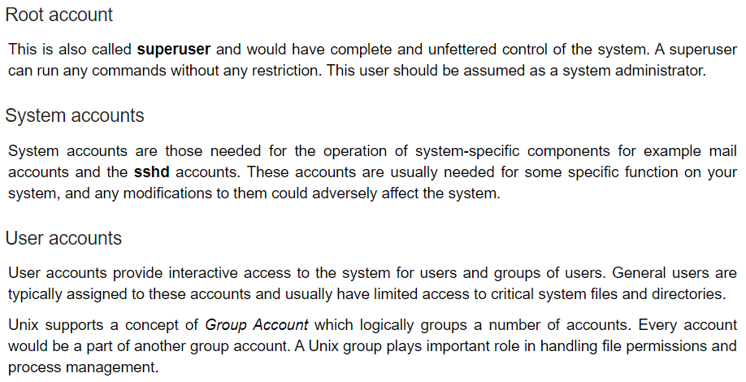

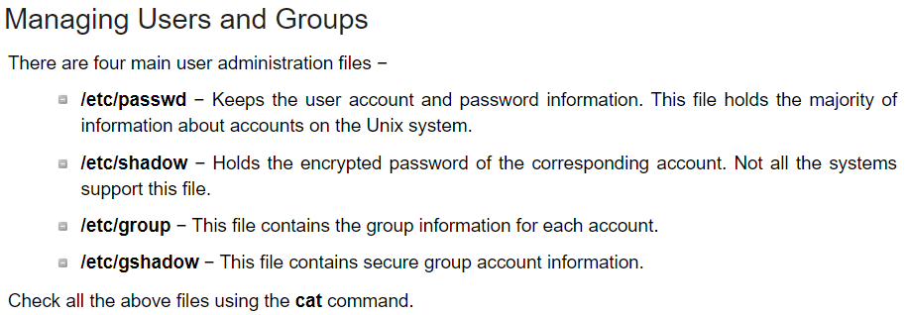

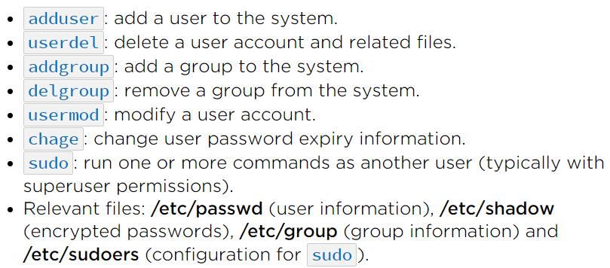

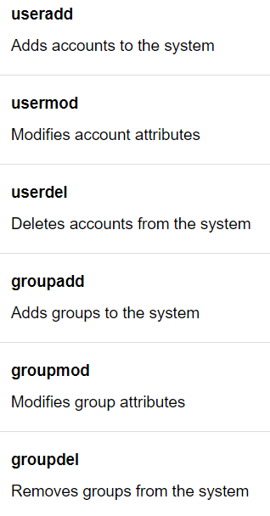

**Adding user account:**

* **useradd [account name]**
* **adduser [account name]**

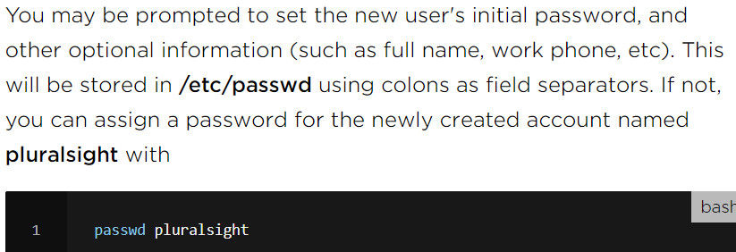

When a new user account is added to the system, the following operations are performed.

* His/her home directory is created (/home/username by default).
* The following hidden files are copied into the user’s home directory and will be used to provide environment variables for his/her user session.

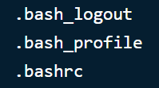

A mail spool is created for the user at /var/spool/mail/username.

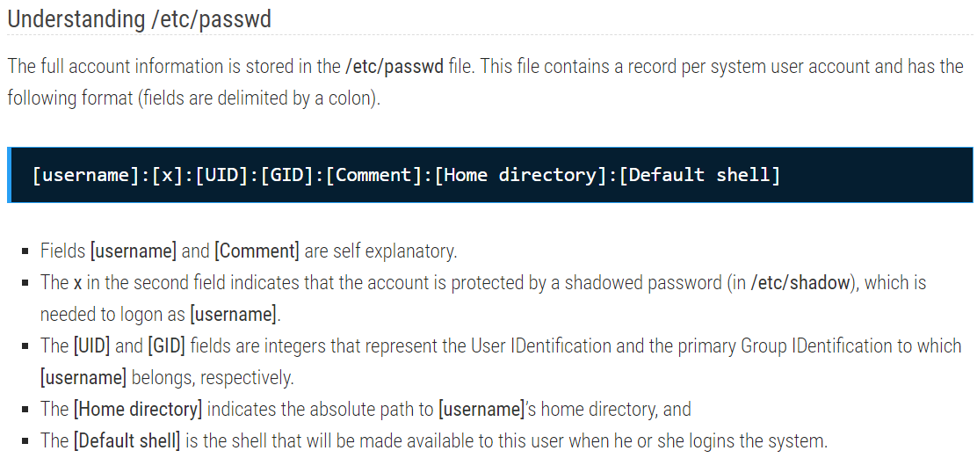

**Modify a user:**

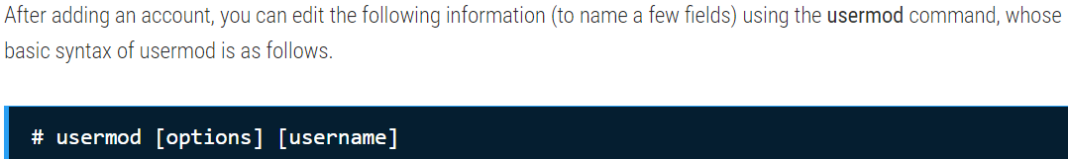

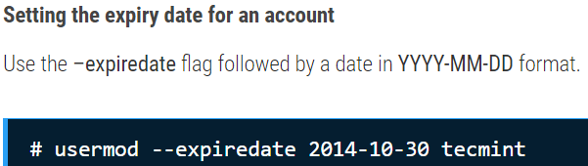

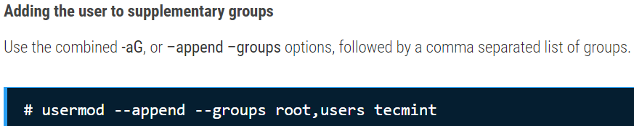

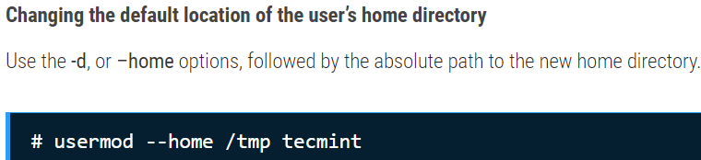

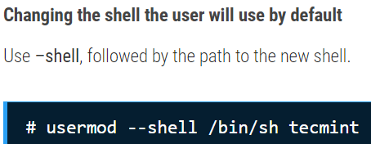

Now let’s execute all the above commands in one go.

* **usermod --expiredate 2014-10-30 --append --groups root,users --home /tmp --shell /bin/sh tecmint**

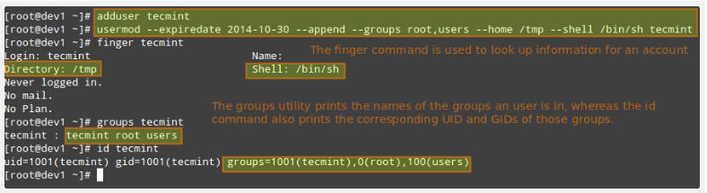

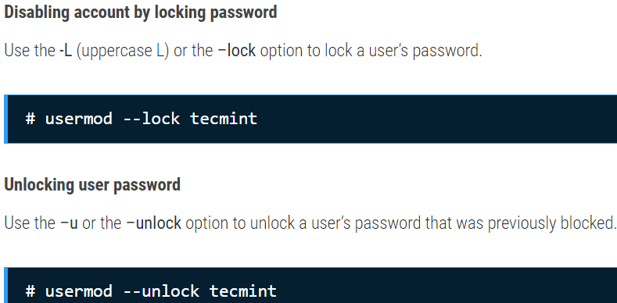

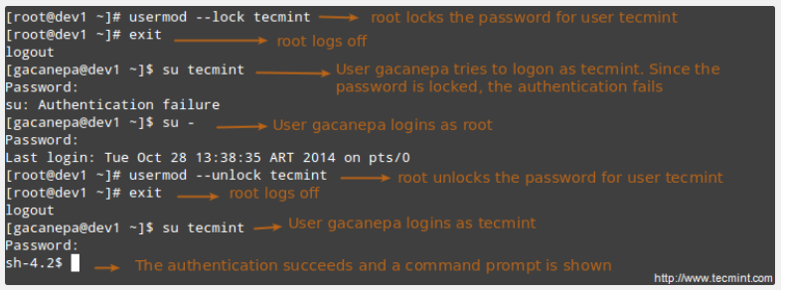

**Creating a group:**

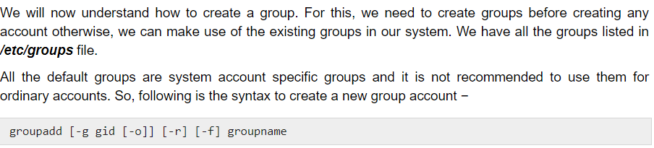

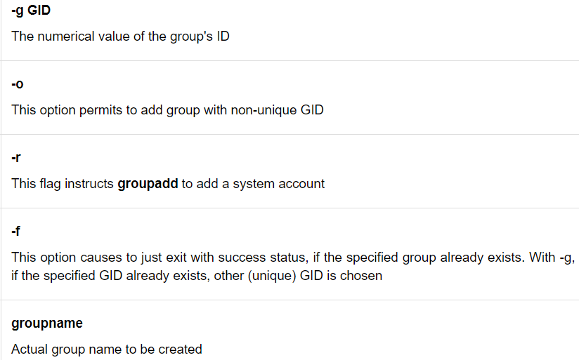

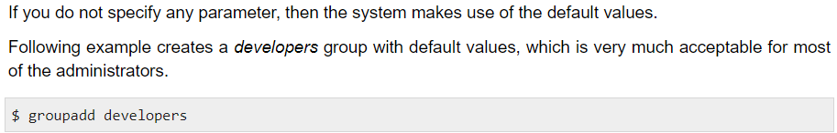

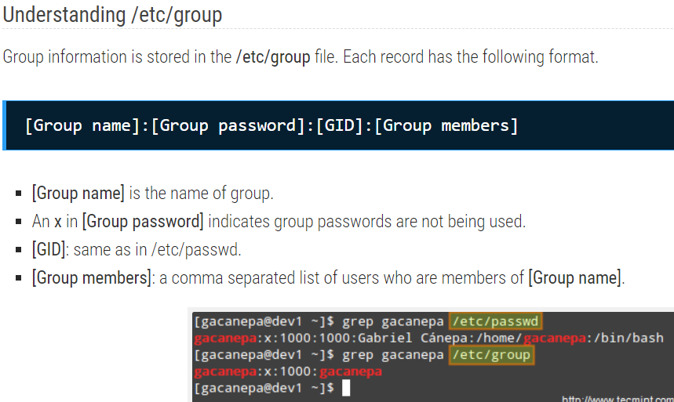

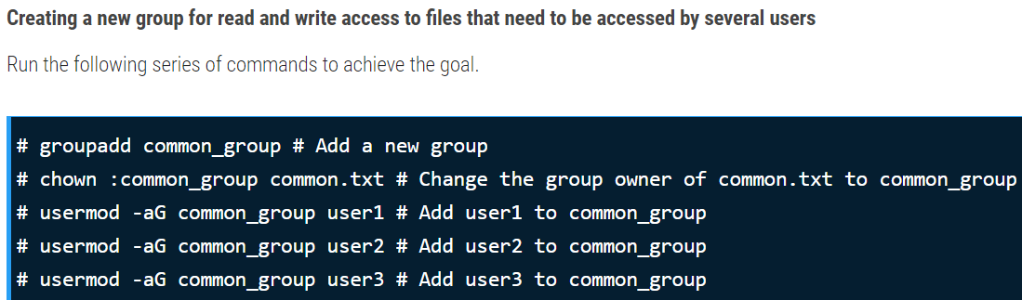

**Modify a group:**

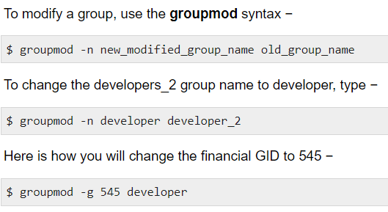v

**Delete a group:**

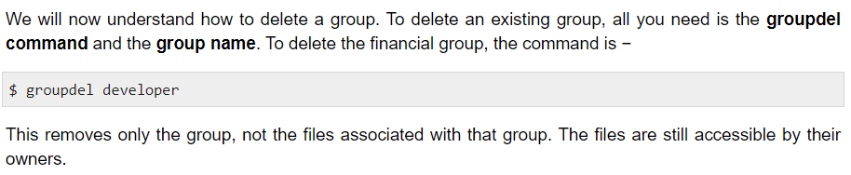

**Create an account:**

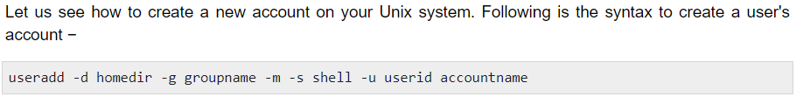

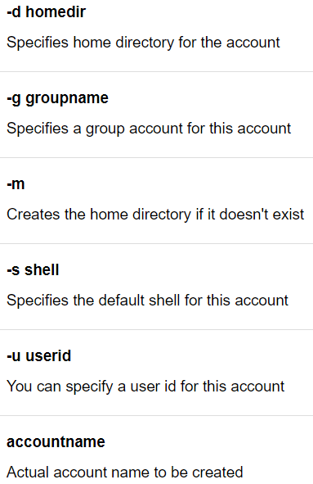

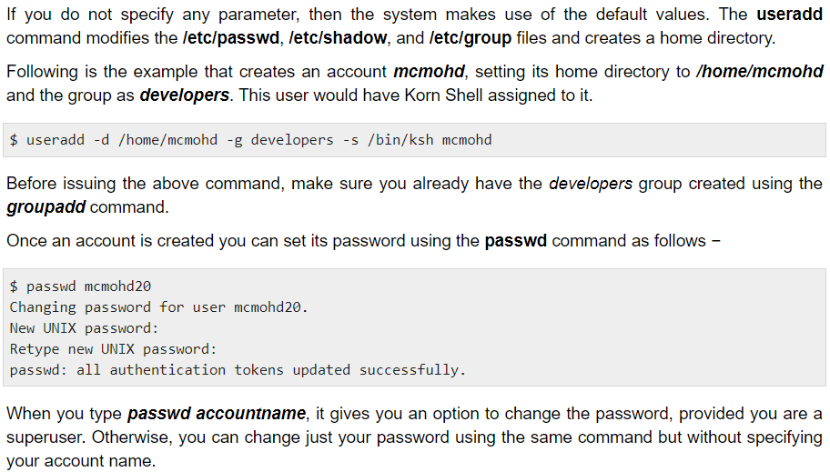

**we may need to manually remove the user from “/etc/group” file to delete an user from a group.**

**Modify an account:**

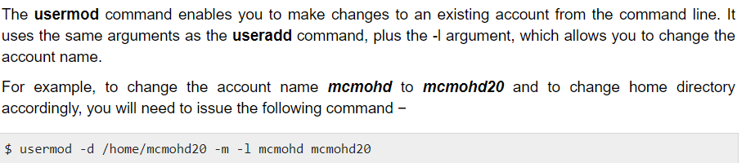

**Delete an account:**

